

CORDOVA PUBLIC COLLEGE
GABI, CORDOVA, CEBU, PHILIPPINES

COLLEGE OF COMPUTER STUDIES

- Software Requirements Specifications
BakeSmart: A Real-Time Delivery Monitoring System
CPC- BSIT-THESIS-SRS-1ST SEM 2025-2026

Documents for IT Project
of
Rey Ann Balo
Jaime Peralta
John Lloyd Racal
- Change History

Version | Date | Author(s) | Description of Changes
V1.0 | April 13, 2026 | Developer Team | Milestone: Initial UI/UX design freeze and prototyping phase.  Feature Added: Designed high-fidelity Figma prototypes for the resident panic button interface and responder dashboard layouts.
V1.1 | April 18, 2026 | Developer Team | Milestone: Successful Capstone 1 Proposal Defense.  Feature Added: Formally presented and defended the application framework, system requirements, and Figma mockups before the BSIT Faculty Panel.
V1.1 | June 9, 2026 | Developer Team | Milestone: Deployment of base user interfaces  Feature Added: Developed responsive frontend application shells using Tailwind CSS, establishing core layout styling, grid systems, and reusable components.
V2.0 | June 20, 2026 | Developer Team | Milestone: Initialization of backend architectural environment.  Feature Added: Setup the Node.js project environment, configured Express application defaults, and structured the core MySQL database models.
V2.1 | July 21, 2026 | Developer Team | Milestone: Core API and routing development.  Feature added: Built secure Express REST API routes for user authentication, real-time location streaming middlewares, and automated incident log creation controllers.
V2.2 | April 21, 2026 | Developer Team | Milestone: Full-stack integration and end-to-end system ending.  Feature Added: Connected frontend client interfaces to Express API endpoints, completing end-to-end asynchronous data flow and dynamic page rendering.

- Table of Contents

Change History ..................................................................................................................26
Table of Contents ...............................................................................................................27
List of Figures ...................................................................................................................28
- Introduction ...............................................................................................................29
  - Purpose ............................................................................................................29
  - Scope ...............................................................................................................30
  - Definitions, Acronyms and Abbreviations ......................................................30
  - References .......................................................................................................31
  - Overview .........................................................................................................31
- Overall Description ...................................................................................................32
  - Product perspective .........................................................................................32
  - Product functions ............................................................................................33
  - User characteristics .........................................................................................34
  - Constraints ......................................................................................................34
2.4. Assumptions and dependencies ........................................................................34
- Specific Requirements .............................................................................................. 35
  - External interface requirements.......................................................................35
    - User interfaces .............................................................................................35
    - Hardware interfaces .....................................................................................42
    - Software interfaces ..................................................................................... 42
    - Communications interfaces .........................................................................43
  - Functional requirements ..................................................................................43
- 3.2.1. High Level Use Case .............................................................................43
- 3.2.2. Android App Control Use Case..............................................................44
- 3.2.3. SMS Control Use Case ..........................................................................45
- Performance Requirements .............................................................................46
- Design constraints ...........................................................................................46
- Software system attributes ..............................................................................46
- Other requirements ..........................................................................................46

- List of Figures

Figure no. 1. | Android App Sign In Option User Interface
Figure no. 2. | Fingerprint Sign In User Interface
Figure no. 3. | Account Sign In User Interface
Figure no. 4.  Figure no. 5. | Create an Account for a new user’s  Google Account Direct Sign In UI
Figure no. 6. | Motorcycle Control User Interface
Figure no. 7. | Motorcycle Fingerprint Activation UI
Figure no. 8. | Voice Command Control UI
Figure no. 9. | SMS Control User Interface
Figure no. 10. | High level Use Case
Figure no. 11.  Figure no. 12. | Android App Control Use Case  SMS Control Use Case

1. Introduction

Most of our daily activities take place outside our home. Because of this, transportation affects every aspect of our lives especially in doing our daily routines such as going to work, school, mall, bank, gym, etc., and even back to our home. Without transportation, there are many activities we could not take part in. Transportation has contributed much to the development of economic, social, political and cultural fields by uplifting their condition. In the Philippines, one of the easy transportations today is the motorcycle and it has increasingly becoming the most common means of transportation.
1.1. Purpose
For future researchers this Software Requirements Specification (SRS) provides a complete description of all the functions and requirement specifications such a hardware and software integration of the 360 Motorcycle Theft Prevention with Android App/SMS Notification Control (3MTPANC). The purpose of this is to know what the requirements are and the functional needed by the client. The researcher gathers all of the data and extracts all this data to make the project successful. The SRS decomposes and break down the problem into component parts. The client must review and approve this document. SRS answers what should be done in the project.

1.2. Scope
The system focuses on managing and monitoring bakery delivery operations. It allows administrators and staff to record customer orders, assign deliveries, track delivery status, and monitor deliveries in real time. Customers can receive updates regarding their orders and delivery progress. The system covers delivery management, order tracking, customer information management, and report generation. However, the system is limited only to bakery delivery monitoring and does not include advanced financial management or inventory control features.
1.3. Definitions, Acronyms and Abbreviations

Definitions
• Real-Time Monitoring – The process of continuously tracking delivery status and location updates as they happen.
• Delivery Personnel – The staff responsible for transporting bakery products to customers.
• System User – Any individual who interacts with the system, including admin, staff, and customers.
Acronyms and Abbreviations
• BakeSmart – BakeSmart: A Real-Time Delivery Monitoring System
• SRS – Software Requirements Specification
• SPMP – Software Project Management Plan
• SDD – Software Design Description
• UI – User Interface
• GPS – Global Positioning System
• SMS – Short Message Service
• BSIT – Bachelor of Science in Information Technology
1.4. References
1.5. Overview
Overview
BakeSmart: A Real-Time Delivery Monitoring System is a proposed system designed to improve the efficiency and reliability of bakery delivery operations through real-time tracking and monitoring. The system provides a centralized platform where administrators, staff, delivery personnel, and customers can manage and monitor delivery transactions effectively.
The system aims to enhance communication, reduce delivery delays, and improve customer satisfaction by providing timely updates and accurate delivery status information. It also supports better organization of delivery records and ensures that orders are properly tracked from preparation up to final delivery.
Overall, the system introduces a modern and efficient approach to managing bakery deliveries by utilizing real-time monitoring technology and user-friendly interfaces.

2. Overall Description
BakeSmart: A Real-Time Delivery Monitoring System is a web and mobile-based system designed to improve and automate the monitoring of bakery delivery operations. The system provides real-time tracking of delivery status, enabling administrators, staff, delivery personnel, and customers to stay updated on order progress from preparation until delivery completion.
The system is intended to streamline delivery processes by improving communication, reducing delays, and minimizing errors in order handling. It also provides an organized platform for managing customer orders, delivery assignments, and status updates in a centralized system.
The system is designed for bakery businesses that require an efficient and reliable delivery monitoring solution. It focuses on enhancing operational efficiency and customer satisfaction through accurate and timely delivery updates.

2.1. Product perspective

BakeSmart: A Real-Time Delivery Monitoring System is a standalone and integrated system designed to support bakery delivery operations. It functions as a centralized platform that connects administrators, staff, delivery personnel, and customers for efficient delivery management and real-time monitoring.
The system is designed to work as a web and mobile-based application, allowing users to access delivery information anytime and anywhere with an internet connection. It may integrate features such as real-time status updates and notification services to ensure smooth communication between all users involved in the delivery process.
Overall, the system serves as a modern solution that improves traditional bakery delivery methods by providing automation, real-time tracking, and better coordination among users.

2.2. Product Functions

BakeSmart: A Real-Time Delivery Monitoring System provides the following main functions to support bakery delivery operations:
• Allows administrators to manage orders, assign deliveries, and monitor all transactions in real time.
• Enables delivery personnel to update the status of deliveries such as “preparing,” “on the way,” and “delivered.”
• Provides customers with real-time tracking and updates regarding their orders.
• Sends notifications and alerts for order status changes and delivery updates.
• Maintains a centralized database for storing customer, order, and delivery information.
• Generates reports for monitoring delivery performance and transaction history.
- key.

2.3. User characteristics

User Characteristics
The users of BakeSmart: A Real-Time Delivery Monitoring System are expected to have different roles and responsibilities within the system. The following are the main user characteristics:
• Administrators – Responsible for managing the overall system, including user accounts, orders, delivery assignments, and monitoring all transactions. They are expected to have basic to advanced computer knowledge.
• Staff / Bakery Personnel – Responsible for encoding customer orders, updating order details, and assisting in managing delivery information. They should have basic knowledge of using web or mobile applications.
• Delivery Personnel – Responsible for delivering orders and updating the delivery status in real time. They are expected to use mobile devices and follow delivery instructions accurately.
• Customers – End users who place orders and track their delivery status. They are expected to have basic knowledge of using mobile phones or web applications to view updates and notifications.

2.4. | Constraints

The development and operation of BakeSmart: A Real-Time Delivery Monitoring System are subject to the following constraints:
• The system depends on a stable internet connection to ensure real-time tracking and updates.
• The accuracy of delivery tracking may be affected by device GPS signal strength and network availability.
• The system is limited to bakery delivery monitoring and does not include full inventory or accounting management features.
• Only authorized users are allowed to access specific system functions to ensure data security and privacy.
• The project must be completed within the given academic timeline, limiting development scope and enhancements.
• System performance may be affected by hardware limitations of user devices.
2.4. Assumptions and dependencies

The system assumes that users (administrators, staff, delivery personnel, and customers) have basic knowledge of using mobile or web applications and have access to internet-enabled devices for real-time system interaction. It is also assumed that delivery personnel will consistently update delivery status to ensure accurate tracking, and that all information entered into the system is correct and valid.
The system depends on a stable internet connection for real-time tracking and notifications. It also relies on a functional database server for storing and retrieving data efficiently. If notification services are integrated, the system may depend on third-party APIs for sending alerts and updates. Proper operation also depends on compatible devices such as smartphones, computers, and supported web browsers.

3. Specific Requirements

3.1. External interface requirements

- 3.1.1. User interfaces


Figure 1: Home Page

It is the first page users will see after searching for and visiting our online bakery website. This page shows information about the website, how customers can order, the different food categories, and the navigation bar.

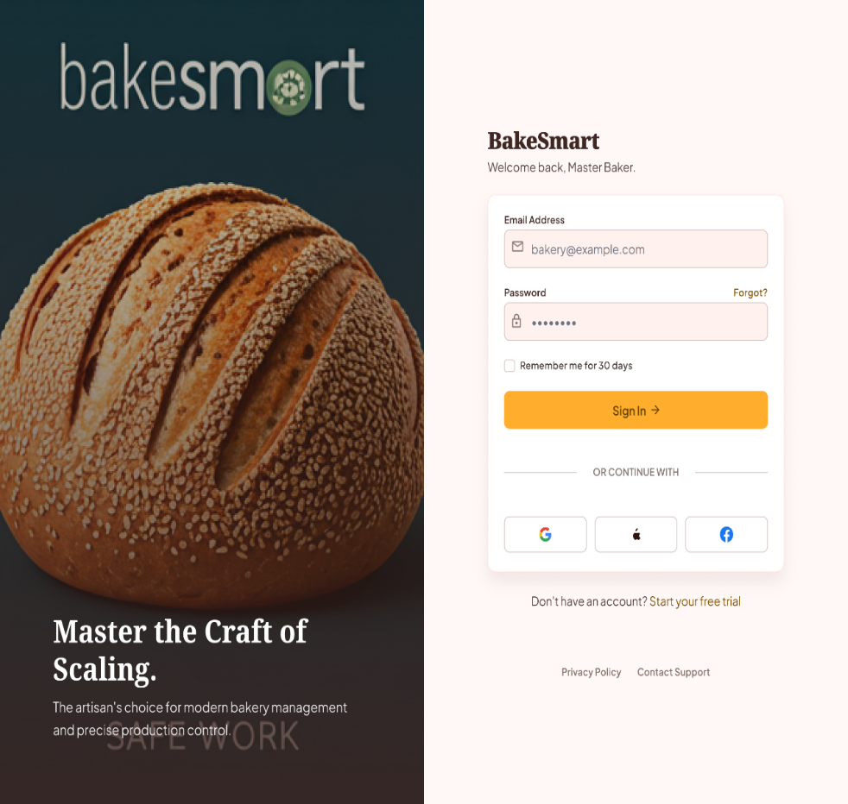

Figure 2:Log In Page
This is the Login Page where users can sign in or create an account using their Google, Apple, or Facebook accounts. It provides a quick and secure way for users to access the system without manually creating a new account. If users already have an account, they can simply log in using their registered credentials. In case they forget their login details, they can recover their account through their linked social media accounts. This ensures easy access and account recovery for all users.

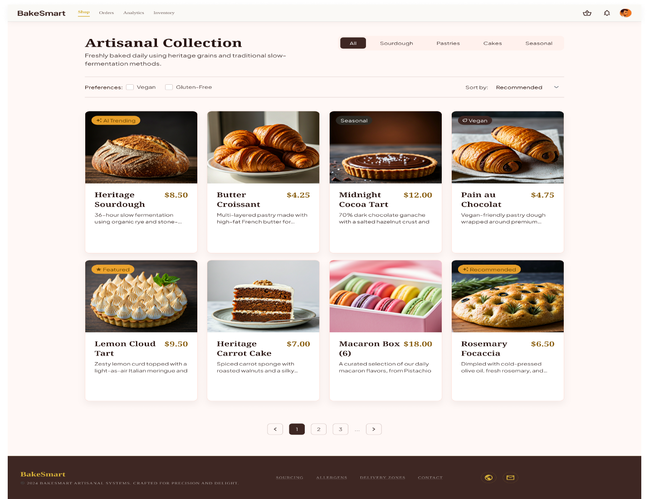
Figure 3:Menu or Shop Page
This is the Shop Page where users can browse, filter, and select from the bakery's "Artisanal Collection." It provides an intuitive interface for customers to explore freshly baked goods by specific categories like pastries or cakes, and quickly narrow down options using dietary preferences such as vegan and gluten-free. Each product card displays a high-quality preview image, price, and clear descriptions to help users make informed decisions before purchasing. This ensures a seamless, visually engaging, and accessible online shopping experience for all bakery customers.
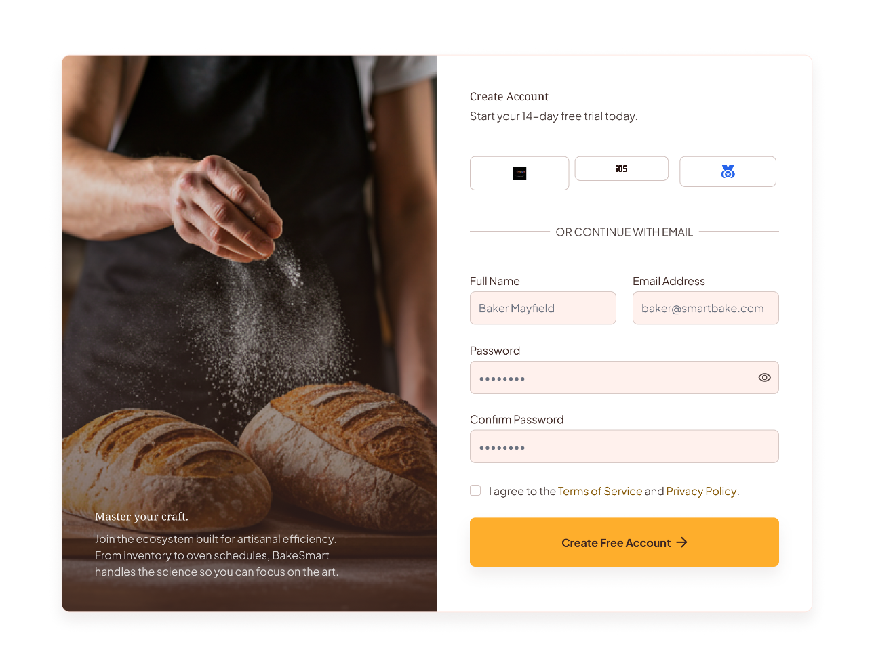
Figure 4:Create Account Page

This is the Create Account Page where new users can register and create their account by providing the required information Full name, Email address, and password or by signing up using their other social accounts.

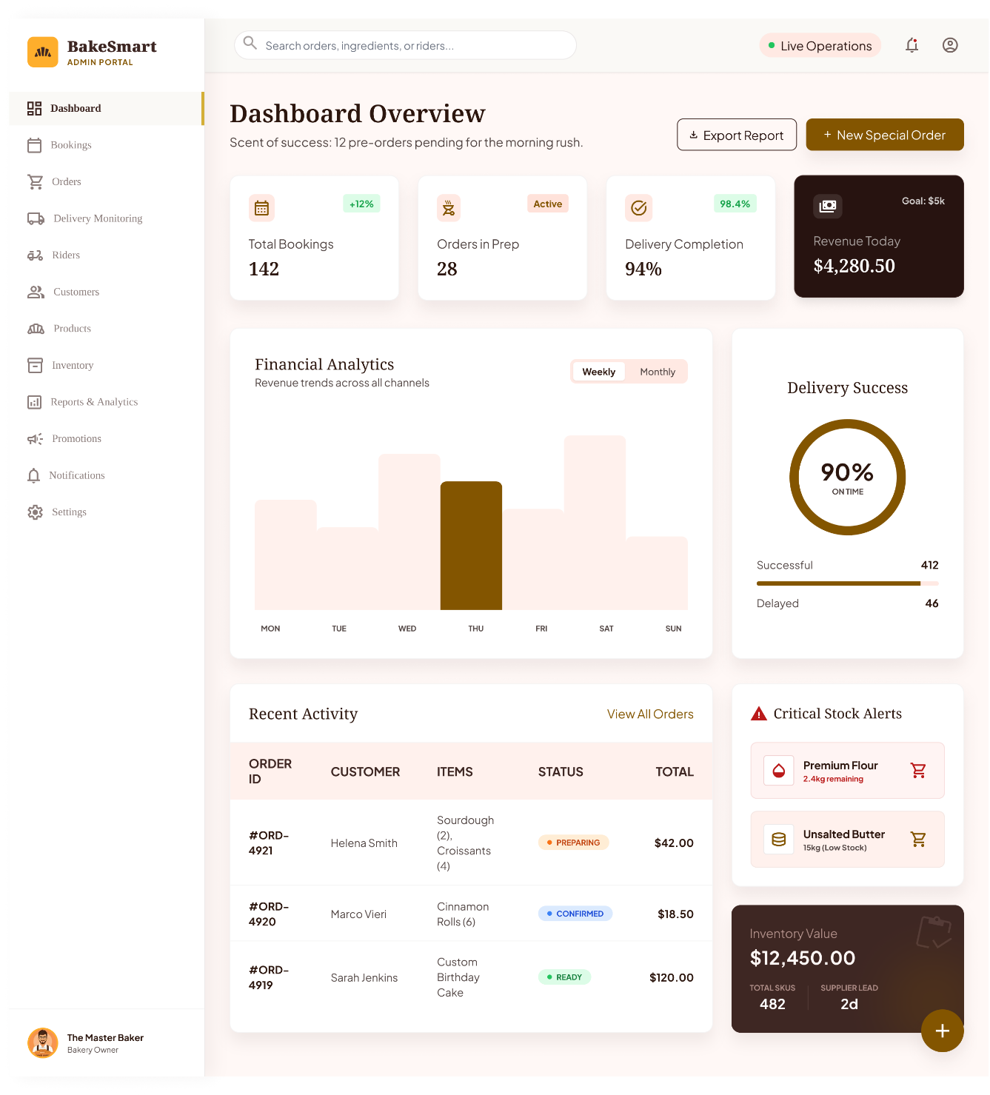
Figure 5:Admin Dashboard Page
This is the Admin Dashboard Page, accessible only by administrators. It displays important system information such as total bookings, orders in preparation, completed deliveries, and revenue. It also provides weekly and monthly financial analytics for monitoring business performance.
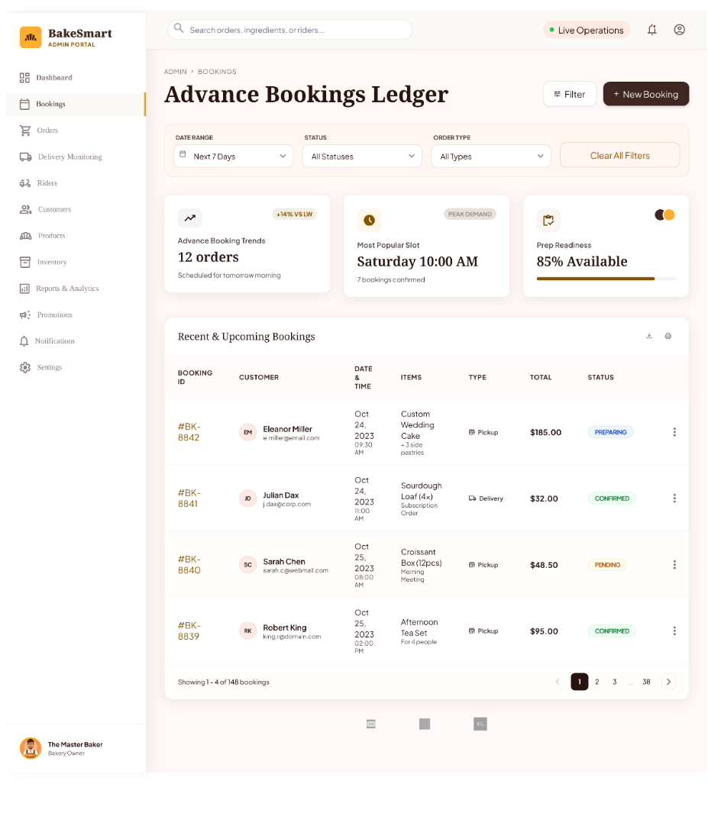

Figure 6:Advance Booking Ledger Page

This is the Advance Booking Ledger Page where all scheduled or pre-orders are recorded. It allows the admin to view, manage, and track upcoming bookings, including order details, customer information, and scheduled delivery dates.

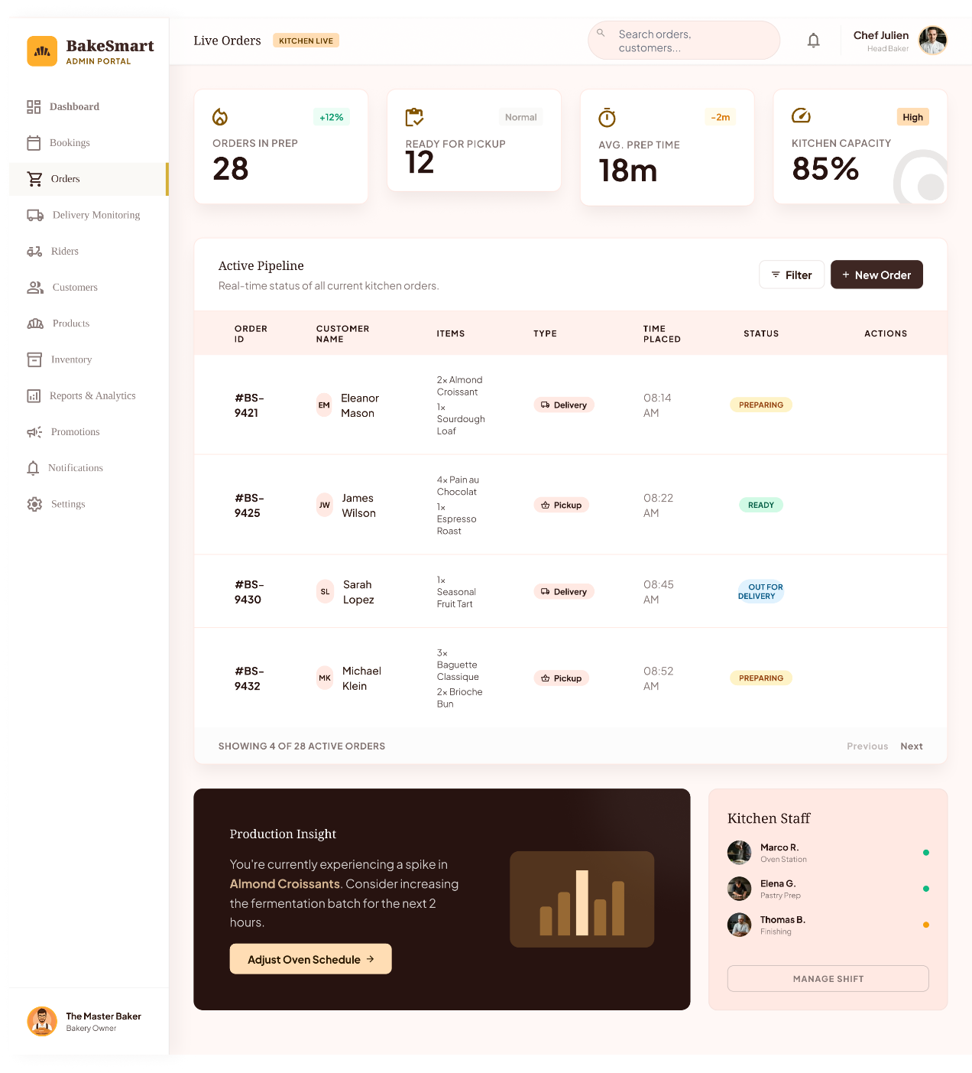
Figure 7 : Order Dashboard Page

This is the Order Dashboard Page where the admin can view and manage all customer orders. It shows order statuses such as pending, in preparation, out for delivery, and completed, allowing easy tracking and updates in real time.

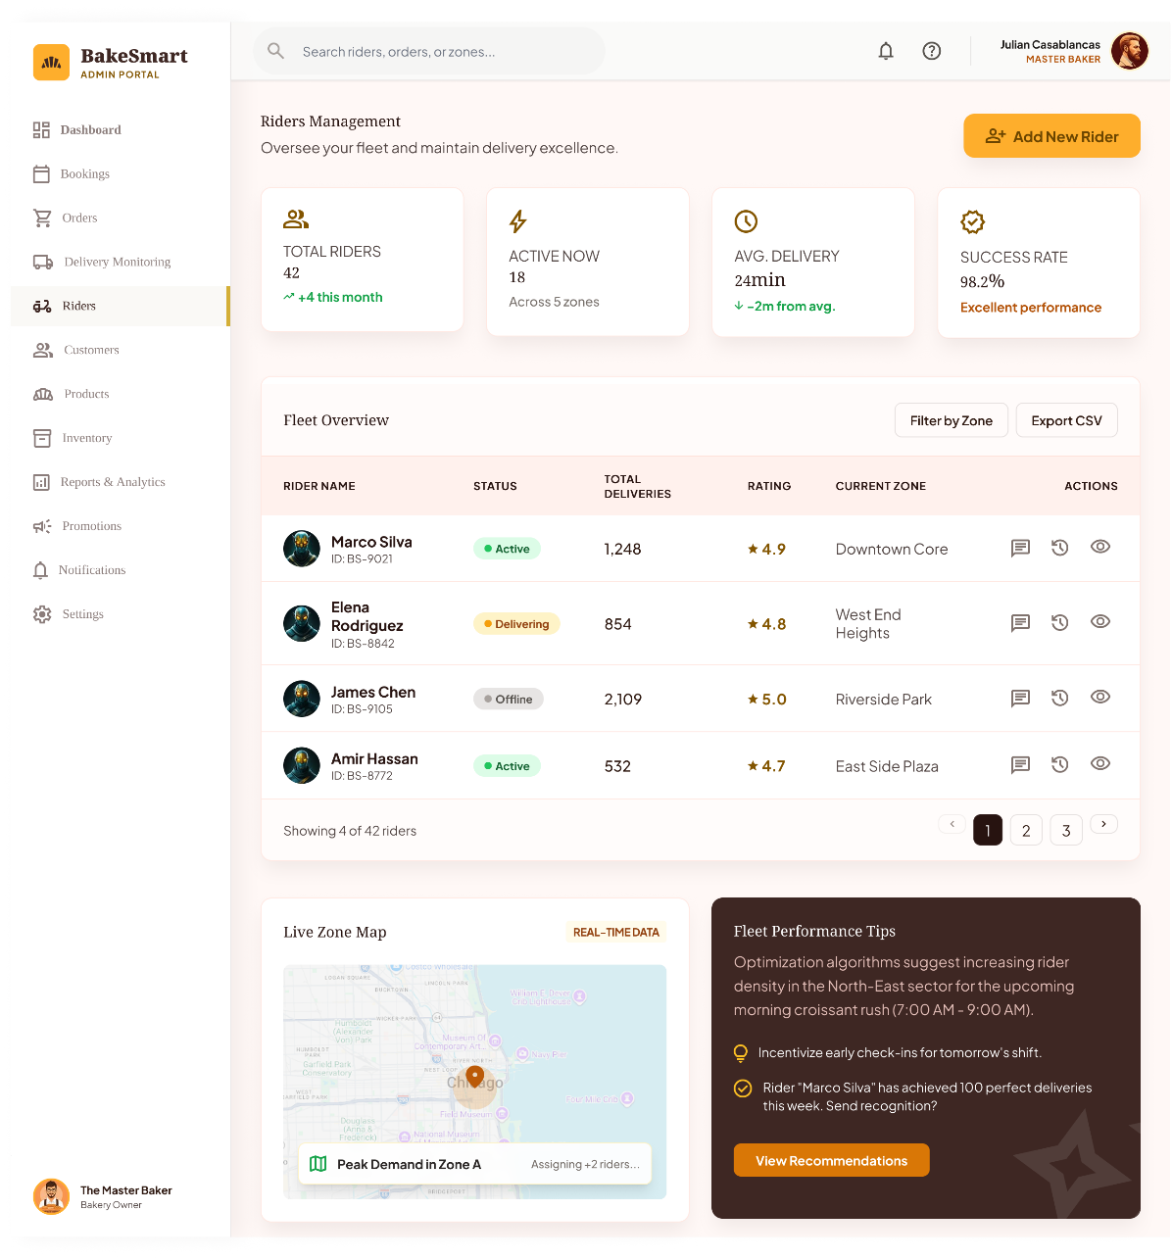

Figure 8 : Rider Dashboard or Riders Page

Rider Dashboard or Riders, where admin can view the statuses of riders, and performance, and peak demand location, where the area most customer orders.

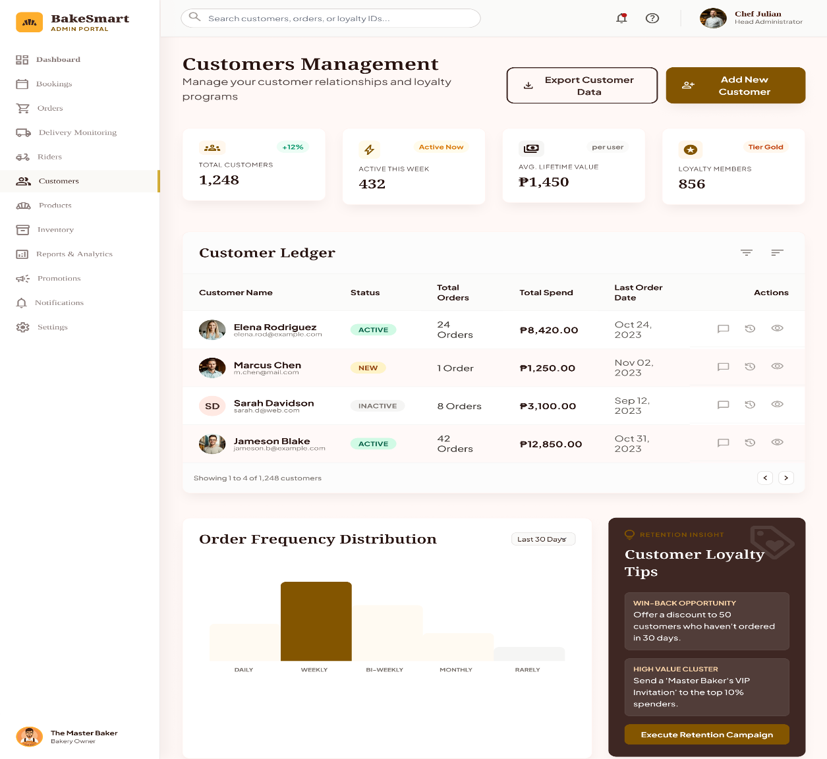
Figure 9: Customer Management Page

This is the Customer Management Page where the admin can view and manage customer details, including total orders, total spending, and the date of their last order.
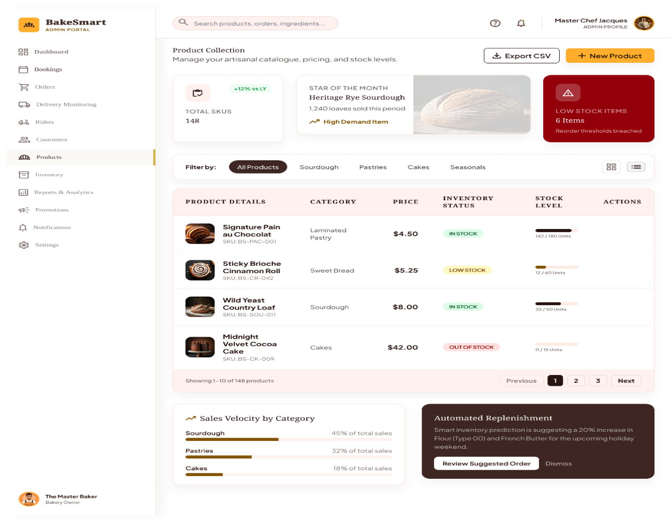

Figure 10 : Products Dashboard Page

This is the Products Dashboard Page where the admin can manage all bakery products. It allows viewing, adding, updating, and removing items, as well as monitoring product availability, prices, and categories.

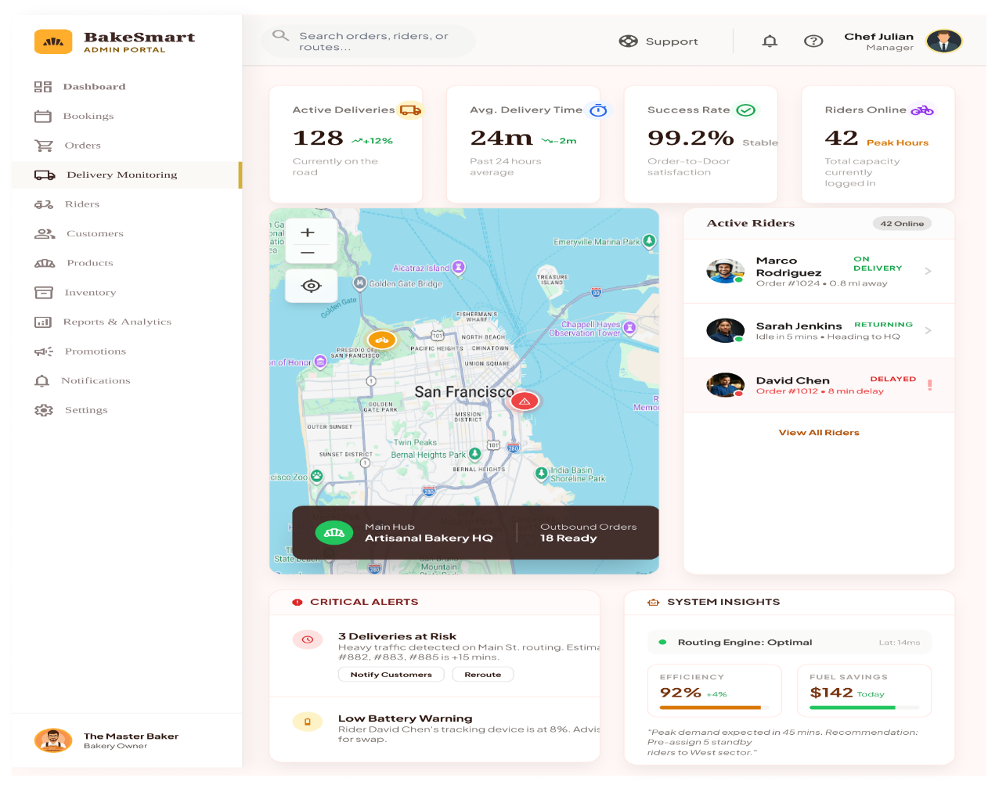

Figure 11: Delivery Monitoring Page

This is the Delivery Monitoring Page where the admin can track all ongoing deliveries in real time. It shows delivery status, assigned riders, order progress, and completed deliveries for efficient monitoring and management.

3.2. Functions
I. User Authentication and Login Function
a. Description: This function allows users of BakeSmart: A Real-Time Delivery Monitoring System to securely access the system by logging in or signing up using Google, Apple, or Facebook accounts. It ensures that only authorized users can enter the system and provides a simple account recovery option through linked social accounts.
b. Actor(s): Administrator, Staff, Delivery Personnel, Customer, Authentication System.
c. The system shall allow users to log in using their valid Google, Apple, or Facebook accounts.
d. The system shall allow new users to register using available social media authentication options.
e. The system shall provide account recovery options through linked social accounts in case of forgotten credentials.
II. Role-Based Access and Dashboard Redirection Function
a. The system shall automatically redirect users to their respective dashboard based on their role (Admin, Staff, Delivery Personnel, Customer) after successful login.
b. The system shall ensure secure session management to keep users logged in during system usage.
c. The system shall restrict unauthorized access to sensitive system features and data based on user roles.

3.3. | Performance Requirements

The BakeSmart: A Real-Time Delivery Monitoring System requires an internet connection for real-time tracking, order updates, and notification features through the web or mobile application. The system depends on online connectivity to allow users such as administrators, staff, delivery personnel, and customers to access updated delivery information and monitor transactions efficiently. Without internet access, real-time updates and notifications may be delayed or unavailable. The system also relies on compatible devices such as smartphones, tablets, and computers to ensure proper access and functionality. Additionally, the accuracy of delivery tracking depends on device location services and stable network availability.
3.4. | Design constraints
The BakeSmart: A Real-Time Delivery Monitoring System must ensure that all software components are properly integrated with the database and external services to avoid system errors and data conflicts. The system must be compatible with different devices such as smartphones, tablets, and web browsers to ensure accessibility for all users. It is also required to maintain a stable internet connection for real-time updates, notifications, and tracking functions.
The system design must follow proper security standards to protect user data and prevent unauthorized access. In addition, the system must be optimized to handle multiple users and transactions simultaneously without affecting performance.

3.5. | Software system attributes

The following attributes are implemented in this system.
- Security- Shows the original position of user’s motorcycle. Then, the system is activated when the user switches the key off and activate/deactivate engine.
- Usability- As the system is easy to handle and navigates in the most expected way with no delays. In that case the system program reacts accordingly and transverses quickly between its states.
- Learnability- Before the user will use the software. Of course, there are tutorial prepared by the developer for accessing the software. There are instructions also.
- Availability- The system will be available to use and help them to carry out the activity conveniently.
3.6. | Other requirements

There are no other requirements

